

**THE UNIVERSITY OF TEXAS AT ARLINGTON, TEXAS  
DEPARTMENT OF ELECTRICAL ENGINEERING**

**EE 5356**

**DIGITAL IMAGE PROCESSING**

**PROJECT # 13**

**by**

**SOUTRIK MAITI**

**1001569883**

**Presented to**

**Dr. K.R.RAO**

**May 3, 2019**

**Image Blending**

***MATLAB Code:***

img_1=imread('lena512.bmp');

img_2=imresize(imread('cameraman.bmp'),[512,512]);

alpha = input('enter alpha value ')

if(alpha<0||alpha>1)

warning('values must range from 0-1')

else

img_3=((1-alpha)*img_1)+(alpha*img_2);

titl=sprintf('the Blended Image for value of alpha=%0.1f',alpha);

imshow(img_3);

title(titl);

end

***Results:***

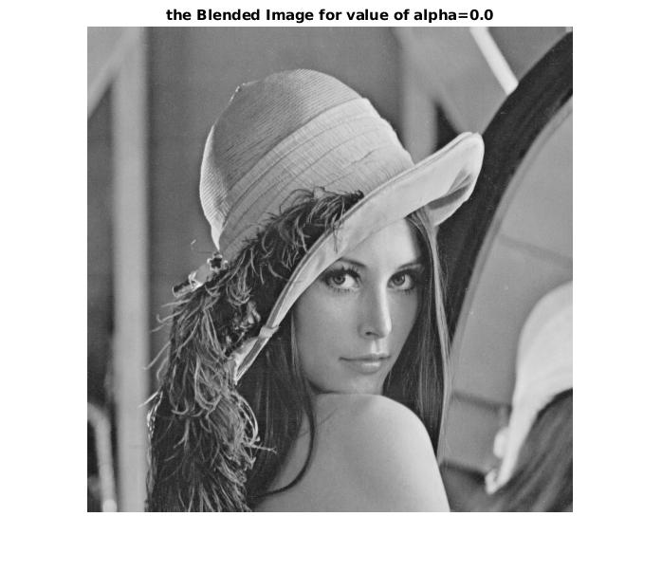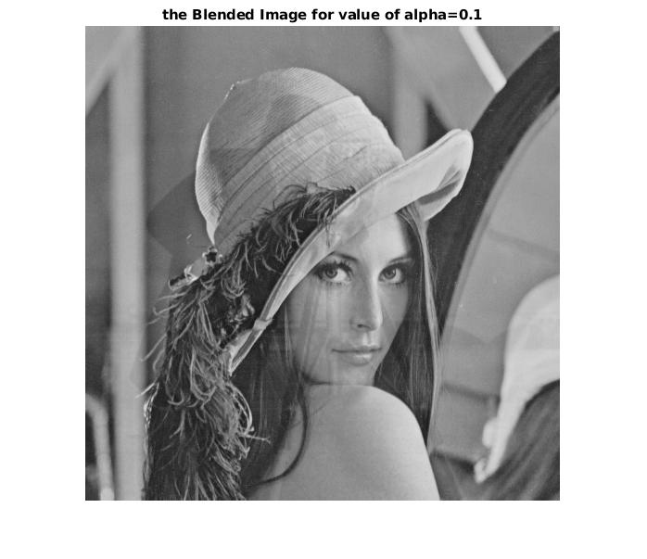

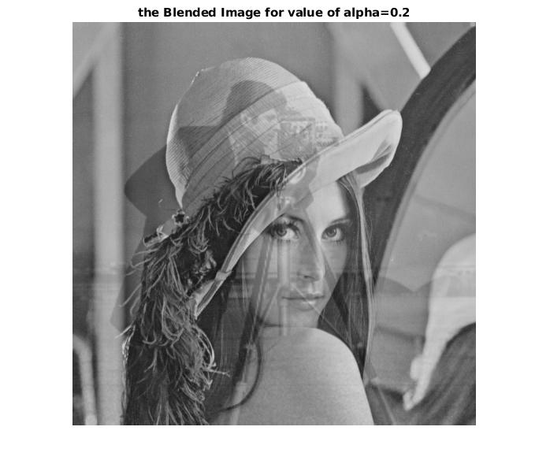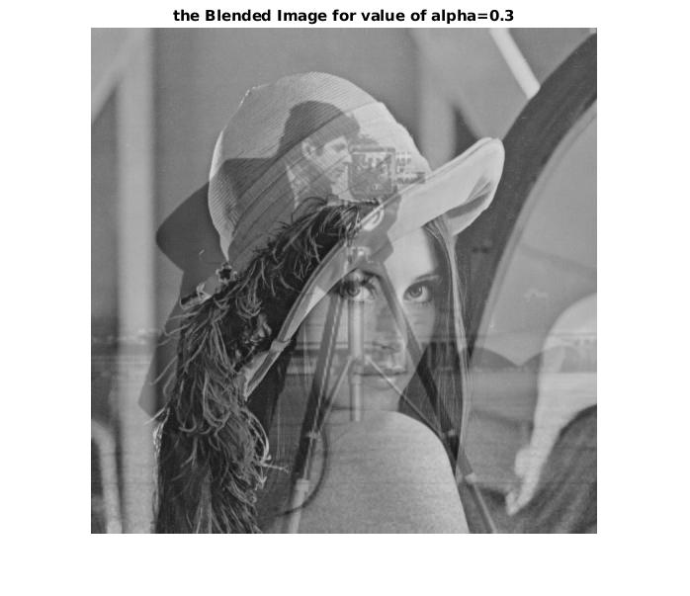

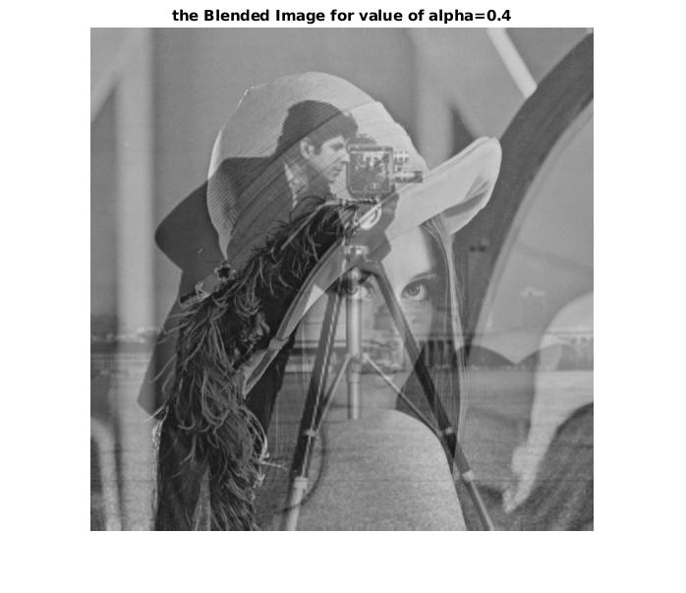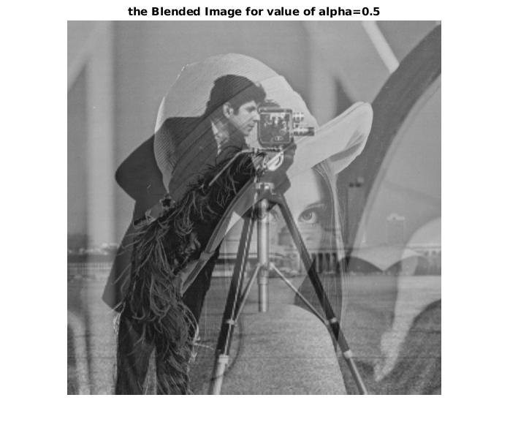

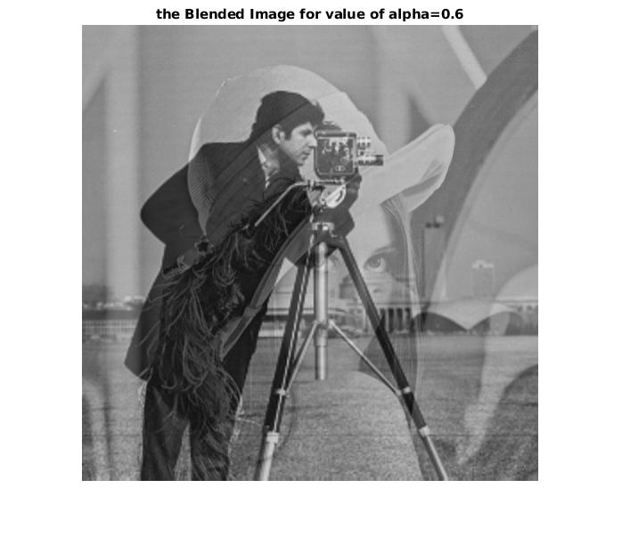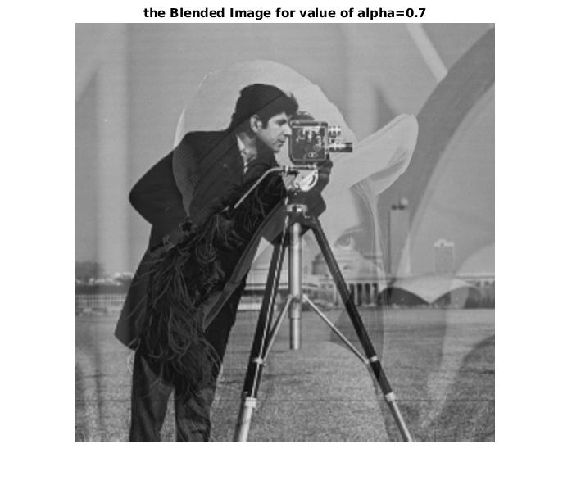

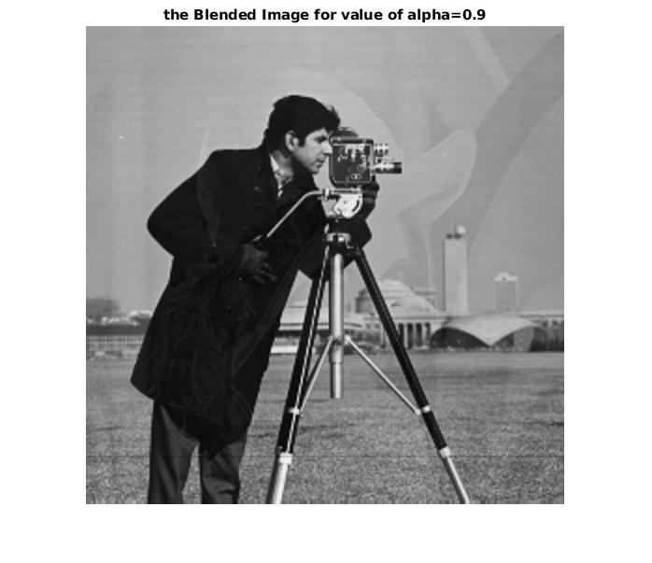

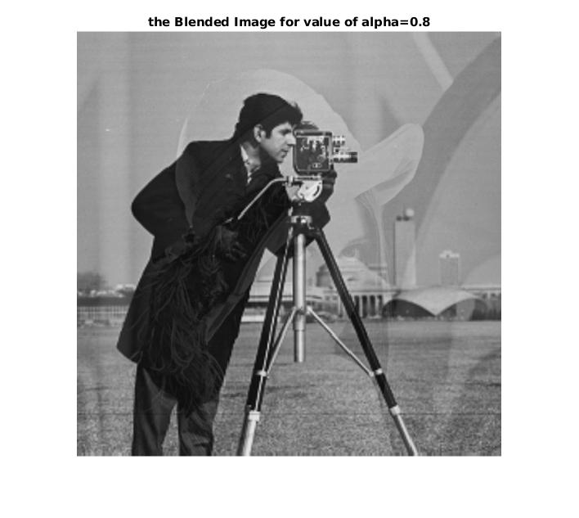

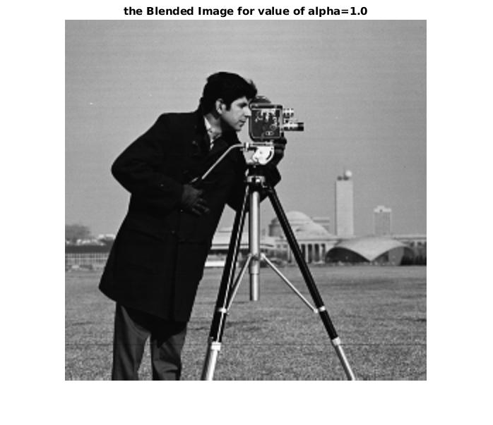

***Conclusion:***

By changing the values of alpha the images have been blended and different levels of blending is displayed based on different alpha values respectively.